TU-100 Emulator
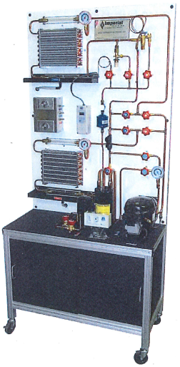

Schematic
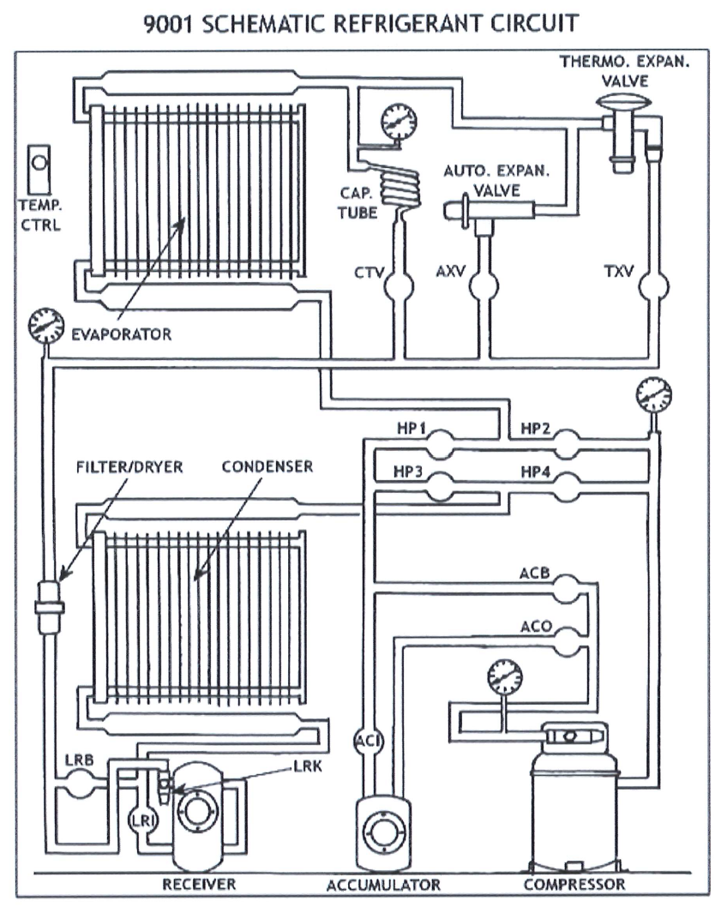

Abbreviations:
Acronym | Description | Acronym | Description
HP1 to HP4 | High pressure valve 1 to valve 4 | CTV | Capillary tube valve
LRI | Liquid receiver inlet | AXV | Automatic expansion valve
LRK | Liquid receiver king valve | ACI | Accumulator inlet
LRB | Liquid receiver bypass | ACO | Accumulator outlet
TXV | Thermostatic expansion valve | ACB | Accumulator bypass
Note: AXV is not emulated.

Digital entities
- 12 Valves (clickable on-off indications)
3 pressure indications (gauges-radial needle movement with digital display on top) with following labels:
- Condenser pressure (Pdis)-Red gauge
- Evaporator pressure (Pevap)-Red gauge
- Suction pressure (Psuc)-Blue gauge
Condenser and evaporator labels will swap at fin-tube heat exchangers if running in heating mode
- 8 temperature indications (temperature pipe clamp with digital display-see below image): 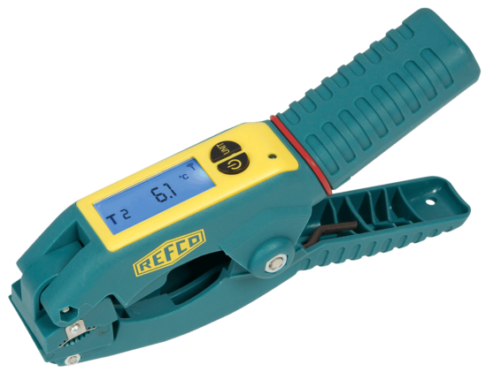
https://refcoswiss.com/en-us/produkte/temperature-clamp-for-refmate-and-tap~p2472
- Discharge (Tdis)
- Condenser outlet (Tco)
- Liquid receiver outlet (Tlro)
- Evaporator outlet (Teo)
- Accumulator outlet (Tacco)
- Suction (Tsuc)
- Ambient air (Tamb)
- Condenser air outlet (Tcondairo)
- Evaporator air outlet (Tevapairo)
Condenser and evaporator labels will swap at fin-tube heat exchangers if running in heating mode
- 2 air flow indications (digital display next to the fin-tube heat exchangers): 6 L/min (tentative value which will be revised in the next draft)
- 2 emulator selections: drop down menu-refrigerant type, slider-ambient air

Valves configurations
Only following valve configurations whose labels are given as follows will run emulation:
- Cooling with TXV, liquid receiver and accumulator
- Heating with TXV, liquid receiver and accumulator
- Cooling with CTV and accumulator
- Heating with CTV and accumulator
- Cooling with TXV and liquid receiver
- Heating with TXV and liquid receiver
- Cooling with CTV
- Heating with CTV
Any column from the following truth table should be satisfied to make the emulation run
 | Cool, TXV with LR and AC | Heat, TXV with LR and AC | Cool, CTV w/o LR and AC | Heat, CTV w/o LR and AC | Cool, TXV with LR and w/o AC | Heat, TXV with LR and w/o AC | Cool, CTV w/o LR and w/o AC | Heat, CTV w/o LR and w/o AC
HP1 | 1 | 0 | 1 | 0 | 1 | 0 | 1 | 0
HP2 | 0 | 1 | 0 | 1 | 0 | 1 | 0 | 1
HP3 | 0 | 1 | 0 | 1 | 0 | 1 | 0 | 1
HP4 | 1 | 0 | 1 | 0 | 1 | 0 | 1 | 0
LRI | 1 | 1 | 0 | 0 | 1 | 1 | 0 | 0
LRK | 1 | 1 | 0 | 0 | 1 | 1 | 0 | 0
LRB | 0 | 0 | 1 | 1 | 0 | 0 | 1 | 1
TXV | 1 | 1 | 0 | 0 | 1 | 1 | 0 | 0
CTV | 0 | 0 | 1 | 1 | 0 | 0 | 1 | 1
ACI | 1 | 1 | 1 | 1 | 0 | 0 | 0 | 0
ACO | 1 | 1 | 1 | 1 | 0 | 0 | 0 | 0
ACB | 0 | 0 | 0 | 0 | 1 | 1 | 1 | 1

Pressure temperature relationships
The gauge pressure-temperature polynomials in units of kPa as function of temperature with units of °C are given below for different refrigerants in the range of -20-70 °C:
R134a: Pdew = Pbubble = 2.087e-06*x^{4} + 0.00089072*x^{3} + 0.14797*x^{2} + 10.616*x + 191.46
Tbubble = Tdew
R290: Pdew = Pbubble = 1.4626e-06*x^{4} + 0.00074114*x^{3} + 0.16485*x^{2} + 14.499*x + 373.11
Tbubble = Tdew
R32: Pdew = Pbubble = 7.1215e-06*x^{4} + 0.0014878*x^{3} + 0.31693*x^{2} + 26.107*x + 711.64
Tbubble = Tdew
R454C:
Pdew = 6.7169e-06*x^{4} + 0.00092632*x^{3} + 0.19689*x^{2} + 15.337*x + 352.44
Pbubble = 4.7174e-07*x^{4} + 0.0010434*x^{3} + 0.21318*x^{2} + 18.288*x + 482.86 (not needed)
For Tbubble estimation, x = Pdew:
Tbubble = - 1.635e-12*x^{4} + 1.383e-08*x^{3} - 4.571e-05*x^{2} + 0.0909*x - 35.07

Emulation logic
Assumed (will revise based on actual operation in next draft): Condenser TD = Evaporator TD = 15 K, Evaporator SH = 5 K, Suction SH = 15 K, Discharge SH = 30 K, Condenser SC = 5 K, Condenser split = Evaporator split = 5 K
Formulae:
Condenser saturation temperature (Tcond) = Condenser TD + Tamb
Condenser pressure (Pdis) = Pdew (Tcond)
Evaporator saturation temperature (Tevap) = Tamb - Evaporator TD
Evaporator pressure (Pevap) = Pdew (Tevap)
Suction pressure (Psuc) = Pdew (Tevap - 5) (5 is tentative. This value will be revised in the next draft)
Discharge (Tdis) = Tcond + Discharge SH
Condenser outlet (Tco) = Tbubble – Condenser SC
Liquid receiver outlet (Tlro) = Tco – 0.1 (0.1 is tentative. This value will be revised in the next draft)
Evaporator outlet (Teo) = Tevap + Evaporator SH
Accumulator outlet (Tacco) = Teo + 1 (1 is tentative. This value will be revised in the next draft)
Suction (Tsuc) = (Tevap – 5) + suction SH (5 is tentative. This value will be revised in the next draft)
Condenser air outlet (Tcondairo) = Tamb + Condenser split
Evaporator air outlet (Tevapairo) = Tamb – Evaporator split

Refrigerant state visualizations
Video recording to be made while the equipment is in operation showing the observed flow in acrylic tubes and sight glass when emulation is running.

